Kareem Ibraheem

**Lab 5 Linux Administration**

1. Compress a file by compress, gzip, zip commands and decompress it again. State the differences between compress and gzip commands.

The “compress” command is the oldest of the bunch and has a relatively low compression effectiveness, while “gzip” is more modern and achieves a far better compression ratio than compress.

1. What is the command used to view the content of a compressed file.

In the case of a zipped file, we use unzip command with the option -l.

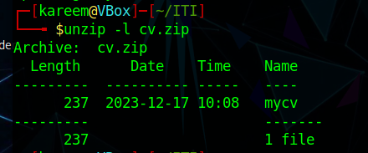

1. Backup /etc directory using tar utility.

1. Starting from your home directory, find all files that were modified in the last two day.

1. Starting from /etc, find files owned by root user.

1. Find all directories in your home directory.

1. Write a command to search for all files on the system that, its name is “.profile”.

1. Identify the file types of the following: /etc/passwd, /dev/pts/0, /etc, /dev/sda

1. List the inode numbers of /, /etc, /etc/hosts.

1. Copy /etc/passwd to your home directory, use the commands diff and cmp, and Edit in the file you copied, and then use these commands again, and check the output.

1. Create a symbolic link of /etc/passwd in /boot.

1. Create a hard link of /etc/passwd in /boot. Could you? Why?

Yes!

